Software Requirements

**R package**

**DAS-COMBAT**

**Document approval and release**

The signatures in the table below ensure that all items in this Software Specifications are accepted by PAMGENE Den Bosch, Netherlands. PAMGENE is responsible for the review and approval of this Software Specifications.

|  |  |  |  |  |
| --- | --- | --- | --- | --- |
| **-** | **Name** | **Function** | **Signature** | **Date** |
|  |  |  |  |  |
| Created by: | **Faris Naji**  **PAMGENE** | Bioinformatics Director |  |  |
|  |  |  |  |  |
| Reviewed by: | **Rik de Wijn**  **PAMGENE** | Head of DAS |  |  |
|  |  |  |  |  |
| Approved by: | **Theo van der leij**  **PAMGENE** | QA Manager |  |  |

**Version history**

|  |  |  |  |
| --- | --- | --- | --- |
| **Version** | **Author** | **Date** | **Description** |
|  |  |  |  |
|  |  |  |  |
|  |  |  |  |
|  |  |  |  |
|  |  |  |  |

**INDEX Page**

1. Introduction3

2. Scope3

2.1. Out of Scope4

3. Definitions4

4. Software requirements Analysis5

4.1. System requirements5

4.2. Software requirements content5

4.3. Risk Control Measures in Software Requirements [Class B, C]9

5. Appendix9

# Introduction

This document defines the software capabilities that must be present for the user to perform the functionalities provided by the software product (SP, i.e. DAS-COMBAT).

# Scope

This software requirement is for the DAS-COMBAT R Package. It is an R Package used in the DAS-NORMALIZE and performs batch correction. The input of the R Package is a pre-processedkinase activity profile measured on DAS and REF using any PAMCHIP. The input is received via the R PACKAGE ENVIRONMENT. The output of the DAS-COMBAT is a corrected version of the input data.

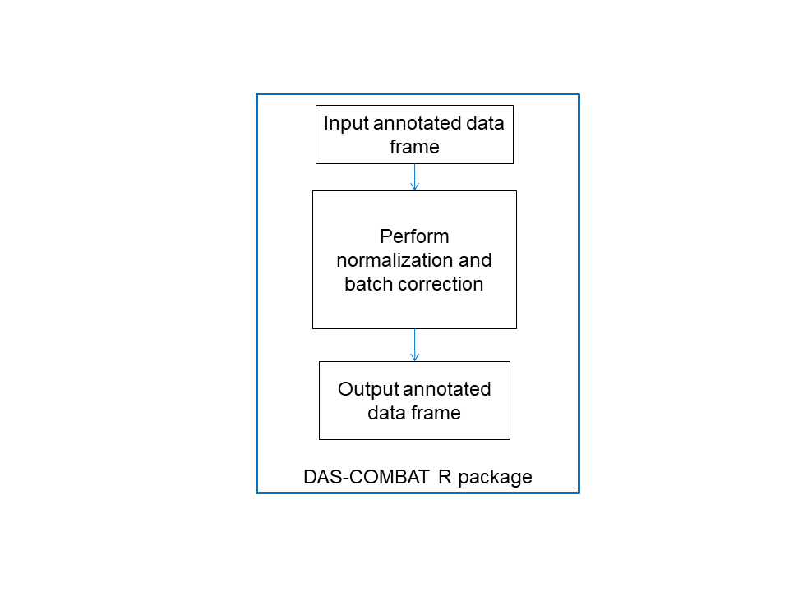

A schematic overview of the R Package architecture is shown above. The DAS-COMBAT R Package performs the following process:

* Receives kinase activity measurement profiles as an annotated data frame
* Calculates the batch correction
* Returns the corrected values as a data frame

## Out of Scope

The R Package DAS-COMBAT will be used with the DAS-NORMALIZE a module of the DAS-PLATFORM. The DAS-PLATFORM is used for image analysis and pre-processing of the measurement data. This legacy software is out of scope for these requirements.

# Definitions

SP Software Product, (i.e. DAS-COMBAT)

|  |  |
| --- | --- |
| SOUP | Software of unknown provenance |
|  |  |

# Software requirements Analysis

The methodology doc referred to in some requirements is appendix A “210228RW19030 Development and verification of the use of reference samples in the DAS lab,”

## System requirements

|  |  |  |
| --- | --- | --- |
| **Req.#** | **Description** | **Class** |
| 002 | DAS-COMBAT receives pre-processed kinase activity profile. The data can be represented as an annotated data frame with columns representing arrays and rows representing the (named) peptides. The elements of the matrix are the measurement values that represent the phosphorylation signal. See requirement req21A1 for detail on the input format. | C |
| 003A1 | The results for DAS-COMBAT is a batch corrected version of the input data table, i.e. containing COMBAT corrected values. | C |
| 005 | Exceptions raised by the DAS-COMBAT will be transmitted to the DAS-COMBAT via the R PACKAGE ENVIRONMENT. | C |

***[Define and document software system requirements from the system level requirement]***

## Software requirements content

### Functional and capability requirements

|  |  |  |
| --- | --- | --- |
| **Req.#** | **Description** | **Class** |
| 011A | SP calculates a batch correction model, i.e. fits a model | C |
| 011B | SP calculates a batch correction i.e. applies a model | C |
| 014A1 | Table 1 is called “**data table”** and defined in req21A1 | C |
| 014A2 | Table 2 is called “**aFITmodel data table”** and defined in req21A2 |  |
| 017A1 | The corrected output table is the same format as the input data table (see req 021A) | C |
| 018A11 | The batch model is defined for: No reference, mean.only = FALSE  data is the input data (see req 021A1)  fit(data, mean.only=FALSE, REF=NULL, batchFactor )  This function implements by performing two calculations   * Standardization of data (see line 32 to 50 of methodology doc) * Fitting of data (see line 51 to 121 of methodology doc)   *aFitmodel data table is returned* |  |
| 018A12 | The batch model is defined for: No reference, mean.only = TRUE  data is the input data (see req 021A1)  fit(data, mean.only=TRUE, REF=NULL, batchFactor = RUNID)  This function implements by performing two calculations   * Standardization of data (see line 32 to 50 of methodology doc) * Fitting of data (see line 147 to 153 of methodology doc)   *aFitmodel data table is returned* |  |
| 018A13 | The batch model is defined for: ref.batch, mean.only = FALSE  data is the input data (see req 021A1)  fit(data, mean.only=FALSE, REF= batchValue, batchFactor)  This function implements by performing two calculations   * Standardization of data (see line 32 to 50 of methodology doc) * Fitting of data (see line 51 to 121 of methodology doc)   *aFitmodel data table is returned* |  |
| 018A14 | The batch model is defined for: ref.batch, mean.only = TRUE  data is the input data (see req 021A1)  fit(data, mean.only=TRUE, REF= batchValue, batchFactor)  This function implements by performing two calculations   * Standardization of data (see line 32 to 50 of methodology doc) * Fitting of data (see line 147 to 153 of methodology doc)   *aFitmodel data table is returned* |  |
| 018A16 | The batch model is applied to data from batches included in the fit  apply(data, MODEL= aFITtable, batchFactor)  Apply correction (see line 122 to 139 of methodology doc)  *what is returned is corrected data table (see req 021A1)* |  |
|  |  |  |
|  |  |  |
|  |  |  |

[Describe the functional and capability requirements that the system need to fulfill]

* *Performance (e.g. purpose of software, timing requirements)*
* *Physical characteristics (e.g. code language, platform, operating system),*
* *Computing environment (e.g. hardware, memory size, processing unit, time zone, network infrastructure) under which the software needs to perform*
* *Need for compatibility with upgrades or multiple SOUP or other device versions*

### Software system inputs and outputs

|  |  |  |
| --- | --- | --- |
| **Req.#** | Description | **Class** |
| 020 | The input is retrieved using the API function of the R PACKAGE ENVIRONMENT | C |
| 021A1 | Data is as an annotated data frame represents a peptide measurement. For each row the following columns are included:  "value"  "rowSeq"  "colSeq"  "ID"  “batchFactor”  Batch factor is a factor indicating the batch of the input data. There is a value of batch factor for each colSeq in the input data.  A batchFactor example is RUNID.  The ID is the peptide ID | C |
| 021A2 | Data is retrieved as a FitModel data table. For each row the following columns are included:  "overall mean" (overall scaling parameter per ID)  "overall scale" (overall scaling parameter per ID)  "mean_per_batch" (batch mean per batch and per ID)  "scale_per_batch" (batch scale per batch and per ID)  “ID” (peptide IDs included in the model)  “batchID” (batches included in the model) |  |
| 022 | Complete arrays only. The DAS-COMBAT checks if there are any missing values. If that is the case the following exception is raised: “missing values are not allowed”. | C |

*[List the inputs and outputs of the system software e.g.:]*

* *Data characteristics (e.g. numerical, alpha numeric, format)*
* *Ranges*
* *Limits*
* *Defaults*

### Interfaces between the software systems and other systems

Not applicable

|  |  |  |
| --- | --- | --- |
| **Req.#** | Description | **Class** |
|  |  |  |
|  |  |  |
|  |  |  |

[Note that if the calculation is done using separate R-packages these should be listed here].

*[List each system interface and identify the functionality of the software to accomplish the system requirement and the interface description to match the system]*

### Software driven alarms, warnings and operator messages

|  |  |  |
| --- | --- | --- |
| **Req.#** | **Description** | **Class** |
| 037 | Any exception returns an informational error message to the DAS-COMBAT via the R PACKAGE ENVIRONMENT. | C |
| 038 | Any exception will result in the execution of the DAS-COMBAT being stopped and the error is non-recoverable. | C |
| 040 | An exception is raised when the input matrix contains any missing values. The informational message is “Missing values are not allowed” | C |
| 042 | Check that the column names of the input data are equal to that defined in req 21A1 and 21A2 | C |
|  |  |  |
|  |  |  |
|  |  |  |

*[Describe all requirements and functionalities that alarm, warning and operator need to fulfill within the system]*

### Security requirements

|  |  |  |
| --- | --- | --- |
| **Req.#** | **Description** | **Class** |
|  | Not applicable the DAS-Platform takes care of security requirements |  |
|  |  |  |

*[Write down the security requirements of the software system e.g.:]*

* *Related to the compromise of sensitive information*
* *Authentication*
* *Authorization*
* *Audit trail*
* *Communication integrity*
* *System security/malware protection*

### User interface requirements implemented by the software

|  |  |  |
| --- | --- | --- |
| **Req.#** | **Description** | **Class** |
|  | Not applicable, the user interface is handled by the DAS-COMBAT | C |

*[List Interface Requirements that need to be implemented by the software, see examples below*:

* *Support for manual operations*
* *Human equipment interactions*
* *Constraints on personnel*
* *Area needing concentrated human attention]*

### Data definition and database requirements

|  |  |  |
| --- | --- | --- |
| **Req.#** | **Description** | **Class** |
| 60 | For “fit” with REF (see req18A13, req18A14) the value of REF must occur in batchFactor |  |
| 61 | For “apply” with FitTable (see req18A15) the values in batchFactor require to be in batchID in the FitTable data (req21A2) |  |

***[****Describe data definition and database requirements below:]*

* *Form*
* *Fit*
* ***Functions***

### Installation and acceptance requirements of the delivered medical device software at the operation and maintenance site

|  |  |  |
| --- | --- | --- |
| **Req.#** | **Description** | **Class** |
| 070 | SP requires passing a test calculation comparing the result to known output. | C |

***[****Specify any installation and acceptance requirements of the delivered software at the operation and maintenance site]*

### Requirements related to methods of operation and maintenance

|  |  |  |
| --- | --- | --- |
| **Req.#** | **Description** | **Class** |
|  | Not applicable, covered by the DAS-COMBAT and DAS laboratory procedures. |  |

*[Identify any applicable requirements related method of operation and maintenance]*

### Requirements related to IT-network aspects

|  |  |  |
| --- | --- | --- |
| **Req.#** | **Description** | **Class** |
|  | Not applicable. DAS-COMBAT is a calculation R Package on single PC. |  |

*[- Network alarms, warnings and operator messages*

* *Network protocols*
* *Handling of unavailability of network services]*

### User Maintenance Requirements

|  |  |  |
| --- | --- | --- |
| **Req.#** | **Description** | **Class** |
|  | Not applicable |  |

*[Identify means for user maintenance requirements]*

### Regulatory Requirements

|  |  |  |
| --- | --- | --- |
| **Req.#** | **Description** | **Class** |
|  | Not applicable for DAS-COMBAT separately. |  |

*[Identify regulatory requirements for the software specifications]*

## Risk Control Measures in Software Requirements [Class B, C]

|  |  |  |
| --- | --- | --- |
| **Req.#** | **Description** | **Class** |
|  |  |  |
|  |  |  |

*[Identify how risk control measures should be implemented.*

*Note: These requirements might not be available at the beginning of the software development and can change as the software is designed and risk control measures are further defined.]*

# 